**Ethics** in **IT**

**Class 8**

**Lab 4**

|  |
| --- |
| Lab Objectives:Ethics in School |

# Hacker

## Hacking has been a part of computing for almost five decades and it is a very broad discipline, which covers a wide range of topics. The first known event of hacking had taken place in 1960 at MIT and at the same time, the term "Hacker" was originated.



# Hacking vs Ethical Hacking

## Hacking is the act of finding the possible entry points that exist in a computer system or a computer network and finally entering into them. Hacking is usually done to gain unauthorized access to a computer system or a computer network, either to harm the systems or to steal sensitive information available on the computer.

## Hacking is usually legal as long as it is being done to find weaknesses in a computer or network system for testing purpose. This sort of hacking is what we call ***Ethical Hacking***.

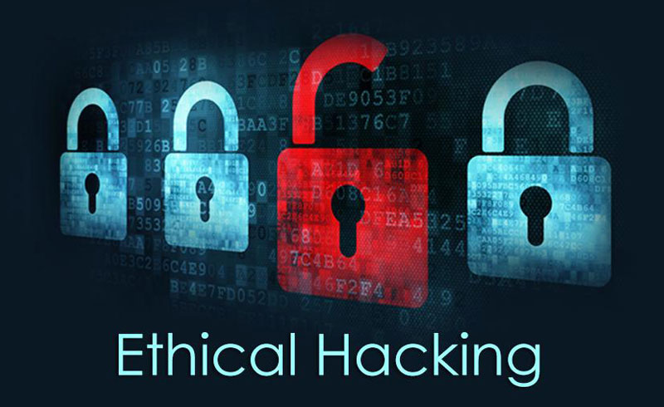

## A computer expert who does the act of hacking is called a "***Hacker***". Hackers are those who seek knowledge, to understand how systems operate, how they are designed, and then attempt to play with these systems.

## Types of Hacking

We can segregate hacking into different categories, based on what is being hacked. Here is a set of examples −

**Website Hacking** − Hacking a website means taking unauthorized control over a web server and its associated software such as databases and other interfaces.

**Network Hacking** − Hacking a network means gathering information about a network by using tools like Telnet, NS lookup, Ping, Tracert, Netstat, etc. with the intent to harm the network system and hamper its operation.

**Email Hacking** − It includes getting unauthorized access on an Email account and using it without taking the consent of its owner.

**Ethical Hacking** − Ethical hacking involves finding weaknesses in a computer or network system for testing purpose and finally getting them fixed.

**Password Hacking** − This is the process of recovering secret passwords from data that has been stored in or transmitted by a computer system.

**Computer Hacking** − This is the process of stealing computer ID and password by applying hacking methods and getting unauthorized access to a computer system.